**THE NOMZ STORY**

Moms (and Dads!) are the best. Growing up, our co-founder distinctly remembers his mother crafting savory stews and freezing the extras. When Mom was away, the kitchen illiterate (i.e., the rest of the family) would heat the frozen stews, add freshly cooked noodles and enjoy a delicious noodle soup whenever they were hungry.

Chicken shiitake mushroom infused with ginger and red dates, spicy braised beef with peppercorns and baby bok choy – the variety was endless and always wholesome, fragrant and super tasty.

Fast forward 20+ years: Time-starved, tired of unhealthy Asian take-out and not impressed by the additives frequently found in Asian store products, our co-founder found himself begging his parents for additional frozen soups from home. When he discovered many of his friends did the same, he realized there existed a significant and mutual desire for restorative and accessible Asian recipes. So we created nomz – wholesome Asian soups for busy individuals and the next best thing when Mom and Dad are far away.

**THE NOMZ TEAM**

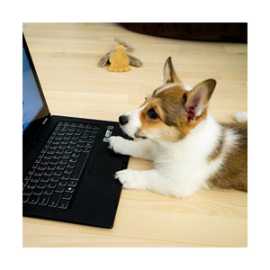

## BAO

Bao is Nomz's resident dog. Her hobbies are eating nomz, waiting for the next nomz cooking session and licking bowls clean.

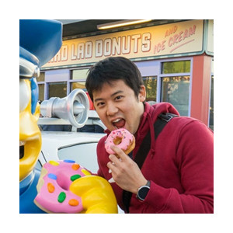

## ERIC

A transplant from Northern California, Eric previously worked as the controller at a startup in the mobile advertising space. In his spare time, Eric likes to eat his way through New York and complain about the weather.



## TONY

A graduate of the Wharton School at the University of Pennsylvania, Tony previously worked in management consulting, private equity and international trade. He loves noups ("noodle soups"), Asian American data and hitting the game-winner in pick-up basketball (it never happens).